**Understanding Inverse Proportion: Real-Life Applications and Calculations**

Being able to mathematically interpret the behavior of one quantity in relation to another is highly useful in many real-life applications. For example, if we know the quantity of flour it takes to make one large pizza, we can calculate the amount of flour required to make three pizzas. However, not all quantities behave in a straightforward manner like flour and the number of pizzas. In this article, we’ll explore how to calculate quantities in indirectly proportional relationships.

**Inverse Proportion**

Two quantities are considered to be in inverse proportion if one quantity increases as the other decreases, or vice versa. Consider a scenario of painting a house. If it takes 5 hours for a painter to paint a room, what would happen to the time taken if 2 painters are working simultaneously? The time decreases. Unlike in the example of the pizza recipe, here as the number of painters increases, the time taken to complete the job decreases. In this scenario, the two quantities—number of painters and time taken—show an inverse proportion relationship.

**Challenge:**

Which of the following quantities shows an indirect proportion relationship

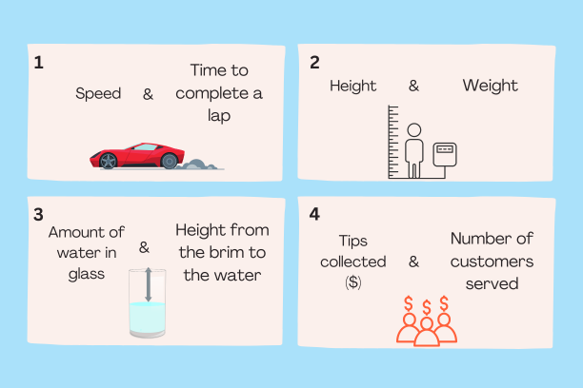

**Answer:**

Scenarios 1 and 3 are examples of inverse proportion. In scenario 2, the two quantities, weight and height, are not related to each other. In scenario 4, the tips collected increase with the number of customers served hence is a direct proportion, not an inverse.

Now that we know how to identify quantities that are in inverse proportion, let’s look at how to perform calculations in such scenarios.

**The inverse proportional formula**

Let us take the average speed of a car and the number of minutes it takes to complete a lap on a race track as x and y respectively.

| Average Speed in km/h (s) | Time Taken in minutes (t) |
| --- | --- |
| 30 | 48 minutes |
| 40 | 36 minutes |
| 60 | 24 minutes |

Clearly, as x (the speed) increases, y (the time taken) decreases, hence the quantities are in inverse proportion. But let’s say we wanted to calculate how much time the car will take to complete the lap at an average speed of 80 km/h or we would like to know at what average speed the car needs to travel to complete the lap within 30 minutes. This is where the inverse proportional formula comes into play:

The inverse proportional formula is used to mathematically represent an inverse proportion relationship. The general form of the inverse proportional formula is:

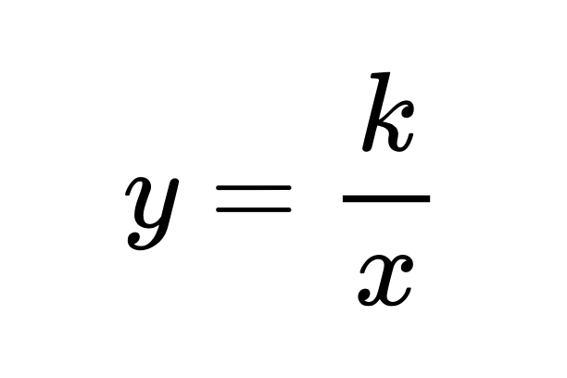

Where y and x are the quantities in an inverse proportion relationship and “k” is the constant of proportionality.

So the formula relating s and t would be:

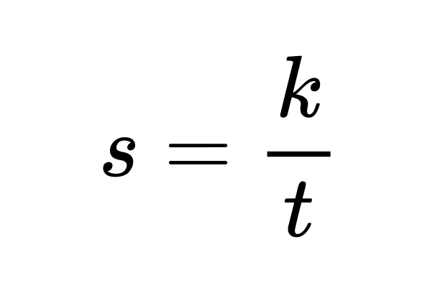

We can use a pair of the recorded values to determine the value of k.

Since we know that at an average speed of 40 km/h, the time taken to complete (y) was 36, we can plug these values into the formula to obtain k.

36 = k/40

k = 40*36

k = 1440

So we can update the formula as:

$s = \frac{1440}{t}$

Now we can use the formula to answer the questions proposed earlier:

1. **How long will the car take to complete the lap at an average speed of 80 km/h?**

Replace s (the average speed) with 80, and solve for t.

$80 = \frac{1440}{t}$

$t = \frac{1440}{80}$

$t = 18$

So it will take 18 minutes.

1. **At what average speed does the car need to travel to complete the lap within 30 minutes?**

This time let’s replace t (the time taken) with 30 and solve for s.

$s = \frac{1440}{t}$

$s = \frac{1440}{30}$

$s = 48$

So the car must travel at an average speed of 48 km/h.

By understanding and applying the concept of inverse proportion, we can solve various real-life problems where one quantity changes inversely with another.